1. Declare a single-dimensional array of 5 integers inside the main method. Traverse the array to print the default values. Then accept records from the user and print the updated values of the array.
2. package org.array.question1;
3. import java.util.Scanner;
4. public class ProgramOne{
5. public static void main(String[] args) {
7. int[] n = new int[] {12,23,4,53,2};
8. System.***out***.println("Default values in the array:");
9. for (int i = 0; i < n.length; i++) {
10. System.***out***.println("Index " + i + ": " + n[i]);
11. }
12. Scanner scanner = new Scanner(System.***in***);
14. System.***out***.println("Enter 5 integers to update the array:");
15. for (int i = 0; i < n.length; i++) {
16. System.***out***.print("Enter value for index " + i + ": ");
17. n[i] = scanner.nextInt();
18. }
19. System.***out***.println("Updated values in the array:");
20. for (int i = 0; i < n.length; i++) {
21. System.***out***.println("Index " + i + ": " + n[i]);
22. }
23. scanner.close();
24. }
25. }

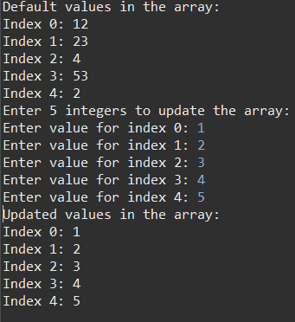

2.Declare a single-dimensional array of 5 integers inside the main method. Define a method named acceptRecord to get input from the terminal into the array and another method named printRecord to print the state of the array to the terminal.

package org.array.question2;

import java.util.Scanner;

public class ProgramTwo{

public static void acceptRecord(int[] arr) {

Scanner sc = new Scanner(System.***in***);

for (int i = 0; i < arr.length; i++) {

System.***out***.print("enter value for index " + i + ": ");

arr[i] = sc.nextInt();

}

sc.close();

}

public static void printRecord(int[] array) {

System.***out***.println("printing array:");

for (int i = 0; i < array.length; i++) {

System.***out***.println("Index " + i + ": " + array[i]);

}

}

public static void main(String[] args) {

int[] arr = new int[5];

*acceptRecord*(arr);

*printRecord*(arr);

}

}

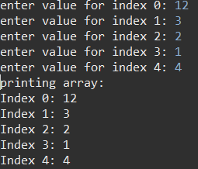

3.Write a program to find the maximum and minimum values in a single-dimensional array of integers.

1. package org.array.question3;
2. import java.util.Scanner;
3. public class ProgramThree {
4. public static void main(String[] args) {
5. // **TODO** Auto-generated method stub
6. Scanner sc = new Scanner(System.***in***);
7. int arr[] = new int[5];
8. for(int i =0; i<arr.length; i++) {
9. System.***out***.println("enter value for " + i+" : ");
10. arr[i] = sc.nextInt();
11. }
12. System.***out***.println("printing array elements : ");
13. for(int i =0; i<arr.length; i++) {
14. System.***out***.print( arr[i] + " ");
15. }
16. System.***out***.println();
18. int max = arr[0];
19. for(int i =1 ; i<arr.length;i++) {
20. if(max < arr[i]) {
21. max = arr[i];
22. }
23. }
24. System.***out***.println("max value : "+ max);
26. int min = arr[0];
27. for(int i =1 ; i<arr.length;i++) {
28. if(min > arr[i]) {
29. min = arr[i];
30. }
31. }
32. System.***out***.println("min value : "+ min);
33. }
34. }

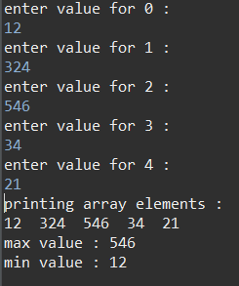

4.Write a program to remove duplicate elements from a single-dimensional array of integers.

package org.array.question4;

import java.util.Arrays;

import java.util.Scanner;

public class ProgramFour {

public static void main(String[] args) {

// **TODO** Auto-generated method stub

Scanner sc = new Scanner (System.***in***);

System.***out***.println("enter the value of elements");

int n = sc.nextInt();

int arr[] = new int [n];

for(int i =0; i<n; i++){

System.***out***.println("enter element value of "+i);

arr[i]= sc.nextInt();

}

int temp [] = new int [n];

int j =0;

Arrays.*sort*(arr);

for(int i =0; i<n-1; i++){

if(arr[i]!=arr[i+1])

temp[j++]=arr[i];

}

temp[j++]=arr[n-1];

for(int k =0; k<j; k++){

System.***out***.print(temp[k] + " ");

}

}

}

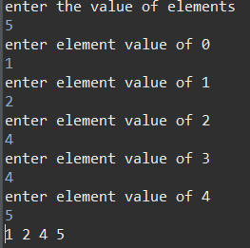

5.Write a program to find the intersection of two single-dimensional arrays.

package org.aaray.question5;

public class ProgramFive {

public static void main(String[] args) {

int[] arr = {1, 2, 3, 4, 5};

int[] arr1 = {1, 3, 4, 7, 2};

int[] temp = *Intersection*(arr, arr1);

for (int value : temp) {

System.***out***.print(value + " ");

}

}

public static int[] Intersection(int[] array1, int[] array2) {

int[] temp = new int[array1.length];

int count = 0;

for (int i = 0; i < array1.length; i++) {

for (int j = 0; j < array2.length; j++) {

if (array1[i] == array2[j]) {

boolean alreadyAdded = false;

for (int k = 0; k < count; k++) {

if (temp[k] == array1[i]) {

alreadyAdded = true;

break;

}

}

if (!alreadyAdded) {

temp[count] = array1[i];

count++;

}

break;

}

}

}

int[] result = new int[count];

for (int i = 0; i < count; i++) {

result[i] = temp[i];

}

return result;

}

}



6.Write a program to find the missing number in an array of integers ranging from 1 to N.

package org.array.question6;

public class Progrma {

public static void main(String[] args) {

// **TODO** Auto-generated method stub

int[] arr = {1,2,4,5,6};

int n = arr.length + 1;

int expectedSum = n*(n+1)/2;

int sum = 0;

for(int element : arr) {

sum += element;

}

int missingNumber = expectedSum - sum;

System.***out***.println("missingnumber : "+missingNumber);

}

}



7.Declare a single-dimensional array as a field inside a class and instantiate it inside the class constructor. Define methods named acceptRecord and printRecord within the class and test their functionality.

package org.array.question7;

class Arrayy {

private int[] arr;

public Arrayy(int size) {

arr = new int[size];

}

public void acceptRecord(int[] inputArr) {

for (int i = 0; i < inputArr.length; i++) {

arr[i] = inputArr[i];

}

}

public void printRecord() {

System.***out***.print("Records: ");

for (int value : arr) {

System.***out***.print(value + " ");

}

System.***out***.println();

}

}

public class Program {

public static void main(String[] args) {

Arrayy p = new Arrayy(4);

int[] num = {10, 23, 43, 5};

p.acceptRecord(num);

p.printRecord();

}

}



8.Modify the previous assignment to use getter and setter methods instead of acceptRecord and printRecord.

package org.array.question8;

import java.util.Arrays;

class Arrayy {

private int[] arr;

public Arrayy(int size) {

arr = new int[size];

}

public String getRecord() {

return Arrays.*toString*(arr);

}

public void setRecord(int[] inputArr) {

for (int i = 0; i < inputArr.length; i++) {

arr[i] = inputArr[i];

}

}

}

public class Program {

public static void main(String[] args) {

Arrayy p = new Arrayy(4);

int[] num = {10, 23, 43, 5};

p.setRecord(num);

System.***out***.println(p.getRecord());

}

}



9.You need to implement a system to manage airplane seat assignments. The airplane has seats arranged in rows and columns. Implement functionalities to:

* Initialize the seating arrangement with a given number of rows and columns.
* Book a seat to mark it as occupied.
* Cancel a booking to mark a seat as available.
* Check seat availability to determine if a specific seat is available.
* Display the current seating chart.
* public class program {
* int count = 0 ;
* public static void main(String[] args) {
* char[][] seats = new char [7][4] ;
* for (int i = 0; i < 7; i++)
* {
* seats[i][0] = 'A' ;
* seats[i][1] = 'B' ;
* seats[i][2] = 'C' ;
* seats[i][3] = 'D' ;
* }
* String seatNumber = " " ;
* int count = 0 ;
* String q = " " ;
* int numberOfSeatsAvailable = 0 ;
* int filled = 0 ;
* System.***out***.println("Welcome") ;
* System.***out***.println("enter the seat like no.A/B/C/D ") ;
* // System.out.println("Enter q to exit.") ;
* Scanner sc = new Scanner(System.***in***) ;
* seatNumber = sc.nextLine() ;
* count++ ;
* if (seatNumber.equals("q"))
* {
* System.***out***.println("Program ended.") ;
* System.*exit*(0) ;
* }
* else
* {
* while((filled < 28) && (seatNumber.length() > 0))
* {
* int row = seatNumber.charAt(0) - '1' ;
* int col = seatNumber.charAt(1) - 'A' ;
* count ++ ;
* if (row < 0 || row > 7 || col < 0 || col > 4)
* {
* System.***out***.println("error");
* seatNumber = sc.nextLine() ;
* count++ ;
* }
* else
* {
* if (seats[row][col] != 'X')
* {
* seats[row][col] = 'X' ;
* filled++;
* System.***out***.println(" ") ;
* *printSeats*(seats);
* }
* if (filled < 28)
* {
* System.***out***.println("Enter seat no," +"exit");
* seatNumber = sc.nextLine();
* count++ ;
* }
* }
* }
* }
* }
* private static void printSeats(char[][] seats)
* {
* int count = 0;
* System.***out***.println("Row") ;
* for (int i = 0; i < seats.length; i++)
* {
* System.***out***.println((i + 1) + " " +
* seats[i][0] + " " + seats[i][1] + " " + seats[i][2] + " " + seats[i][3]) ;
* }
* count++ ;
* int numberOfSeatsAvailable = 0 ;
* numberOfSeatsAvailable = (28 - count) ;
* System.***out***.println("There are " + numberOfSeatsAvailable + " seats available.") ;
* }
* }

